**EQ OFFICES UPDATE GUIDE**

1. **Create “Privacy Policy” Page**

Please place link to a Privacy Policy page as indicated in red below. It should appear on all pages.



The text on the “Privacy Policy” page should be as follows:

PRIVACY POLICY

EQ Offices Inc. is committed to respecting the privacy of individuals and organizations and recognizes a need for the appropriate management and protection of any personal information that you agree to provide us. We will not share your information with any third party outside of our organization, other than as necessary to fulfill your request.

If you have any questions regarding this policy, please email us: info@eqoffices.com

1. **“Book a Tour” Button**

Please add a “Book a Tour” button to the top of the Homepage picture slider as pictured below. It should have a black fill (30% transparency), white outline, and white text in all caps. Circles indicating slide transitions should be moved to the bottom.

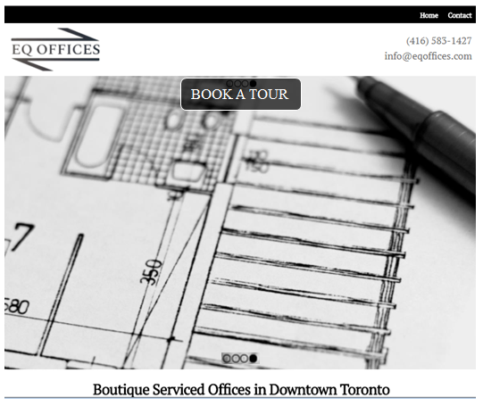

The button should take the client directly to the Contact Form position:

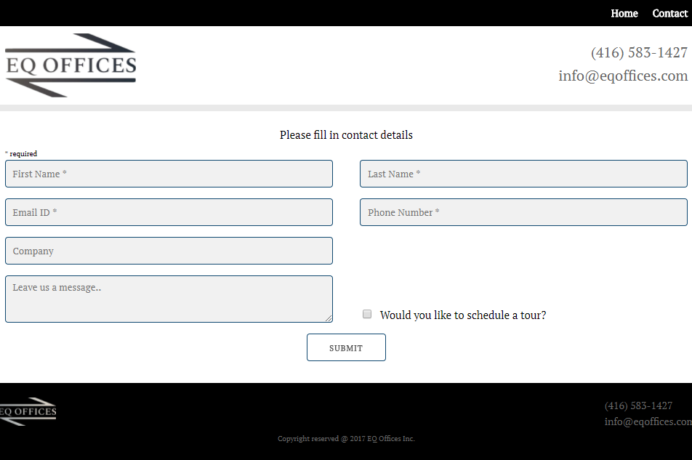

1. **Create New Page – “Options”**

Create a new page called “Options”. The layout should be as below, except using the website styles and fonts. With respect to the box style, please use your excellent design judgement.

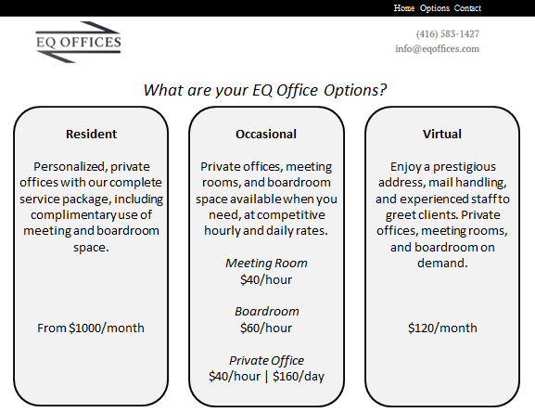

The text for the “Options” page is as follows:

**What are your EQ Office Options?**

|  |  |  |
| --- | --- | --- |
| **Resident** | **Occasional** | **Virtual** |
| Personalized, private offices with our complete service package, including complimentary use of meeting and boardroom space.  From $1000/month | Private offices, meeting rooms, and boardroom space available when you need, at competitive hourly and daily rates.  *Meeting Room*  $40/hour  *Boardroom*  60/hour  *Private Office*  $40/hour | $160/day | Enjoy a prestigious address, mail handling, and experienced staff to greet clients. Private offices, meeting rooms, and boardroom on demand.  $120/month |

Lastly, remove the “What are your EQ Options?” block from the homepage.

1. **Homepage “What’s Included” Section**

Please centre the “What’s Included” section on the homepage

Please list the following:

* Fully serviced & furnished offices for 1 to 16 people
* Dedicated reception & mail handling
* Onsite support team
* Secure high-speed internet
* Integrated IP telephony
* Boardroom & meeting rooms
* Complimentary scanning/printing/copying
* Complimentary coffee, tea, & filtered water
* Daily professional cleaning
* Property fees, utilities & maintenance

1. **Favicon**

Please add a favicon of our logo with a transparent background.

1. **Annotate Code**

Please add comments to the code for each page to explain function.

**Thank you!**